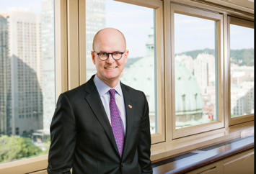

PAUL DEEGAN

Paul Deegan is President and CEO of News Media Canada – the voice of the print and digital media in Canada, representing hundreds of trusted titles in every province and territory.

From 2015 to 2018, he was Vice-President, Public and Government Affairs at Canadian National Railway Company. He had North American responsibility for CN’s relationships with governments at all levels as well as media relations, social media, corporate advertising, sponsorships and donations, community relations, and internal communications.

Mr. Deegan joined BMO Financial Group in 1996 as a policy adviser in the CEO’s office. From 2009 to 2015 – a period which included the global financial crisis and a transformative acquisition by BMO – he was Vice-President, Government and Public Relations.

Prior to joining BMO, Mr. Deegan served as Deputy Executive Director of the National Economic Council in the Clinton White House and worked for the Government of Ontario’s Cabinet Office. He also interned in the office of the late United States Senator Edward M. Kennedy and at the Democratic National Committee.

He studied at McGill, and graduated from University of Toronto in History and Political Science. While at BMO, he completed two advanced executive programs with the Ivey/Kellogg and Rotman business schools.

Mr. Deegan is a director of the Canadian Journalism Foundation and the Michener Awards Foundation. He is a member of the Canadian Investment Committee of the Society of the Sacred Heart, and he is a member of the BlackNorth Initiative’s Government Relations & Public Sector Committee. He is a past director of Toronto Terminals Railway Co. Ltd., Toronto Financial Services Alliance, Necessary Angel Theatre Company, Tarragon Theatre, and Aptus Treatment Centre for Complex Disabilities. In 2017, Mr. Deegan was named an Honorary Captain of the Royal Canadian Navy by the Minister of Defence. He is a contributing writer to Policy Magazine. In 2018, he was appointed to the Acquisition Committee – International Art after 1900 – at the Montreal Museum of Fine Arts. He is married with two children.

